FALSE POSITIVES AND FALSE NEGATIVES

False positive is when you predict that something will happen but it actually does not happen.

This is Type 1 Error.

False negative is when you predict that something won’t happen but it does actually happen.

This is Type 2 Error.

CONFUSION MATRIX

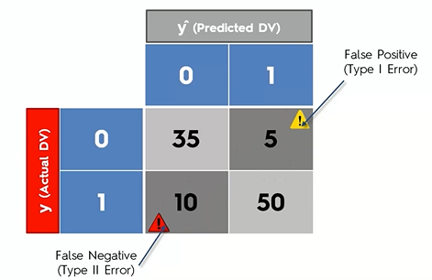

The more you have in your left diagonal, the better

The more you have in your right diagonal, the worse

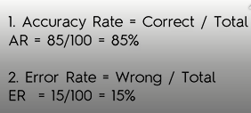

ACCURACY PARADOX

Let there be 10,000 observations.

150 Type 1 Errors

50 Type 2 Errors

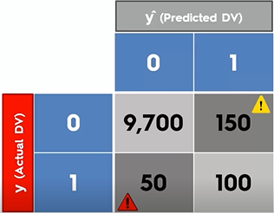

Scenario 1:

Accuracy Rate = correct/total = 9800/10000 = 98%

Scenario 2:

Now we are going to tell the model to stop predicting and from now onwards our prediction is always going to be zero.

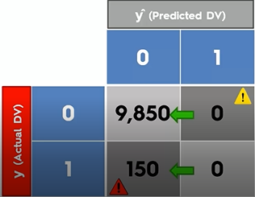

Now, Accuracy Rate = 9850/10000 = 98.5%

Accuracy rate went up by half percent.

Here we just stopped using a model but the accuracy rate went up. And that is why we should not base our judgment just on accuracy because things like this can happen and even though we not using a model any more which means that we are not applying any kind of logic into our decision making process our accuracy rate is going up so it's misleading us into a wrong conclusion that we should stop using models and this effect is called the accuracy paradox.